[Date]

IT INDUSTRY

Kirtan Khokhar

Admin

tops technologies

1. **what is software? What is software engineering**?

Computer software, or just software, is a collection of computer programs and related data that provides the instructions. It can not be touched. Hardware and other task does not work without Software.

Software refers to a set of instructions, data, or programs used to operate computers and execute specific tasks. It is the non-tangible component of computers, in contrast to hardware, which refers to the physical devices. Software is essential for the functioning of computer systems and can be broadly categorized into several types.

In a [computer system](https://www.geeksforgeeks.org/basics-of-computer-and-its-operations/), the software is basically a set of instructions or commands that tell a computer what to do. In other words, the software is a computer program that provides a set of instructions to execute a user’s commands and tell the computer what to do. For c

 instructions that tell a computer what to do. Software [comprises](https://www.merriam-webster.com/dictionary/comprises) the entire set of programs, procedures, and routines associated with the operation of a [computer system](https://www.britannica.com/technology/computer). The term was coined to [differentiate](https://www.merriam-webster.com/dictionary/differentiate) these instructions from [hardware](https://www.britannica.com/technology/hardware-computing)—i.e., the physical components of a computer system. A set of instructions that directs a computer’s hardware to perform a task is called a program, or software program.

Without software, most computers would be useless. For example, a [web browser](https://www.webopedia.com/definitions/browser/) is a software application that allows users to access the internet. Without it, reading this page on Webopedia wouldn’t be possible.

Similarly, an [operating system](https://www.webopedia.com/definitions/operating-system/) (OS) serves as the [interface](https://www.webopedia.com/definitions/interface/) between other applications and the hardware on a computer or mobile device. [TCP/IP](https://www.webopedia.com/definitions/tcp-ip/) is built into all major operating systems to allow computers to communicate over long distance networks. Without the OS or the protocols built into it, it wouldn’t be possible to access a web browser.

Software is a set of instructions, [data](https://www.webopedia.com/definitions/data/), or [programs](https://www.webopedia.com/definitions/program/) used to operate a [computer](https://www.webopedia.com/definitions/computer/) and execute specific tasks. In simpler terms, it tells a computer how to function. It’s a generic term used to refer to [applications](https://www.webopedia.com/definitions/application-software/), [scripts](https://www.webopedia.com/definitions/script/), and programs that run on devices such as [PCs](https://www.webopedia.com/definitions/personal-computer/), [mobile phones](https://www.webopedia.com/definitions/mobile-phone/), [tablets](https://www.webopedia.com/definitions/tablet-pc/), and other smart devices. This contrasts with [hardware](https://www.webopedia.com/definitions/hardware/), which is the physical aspects of a computer that perform the work.

Have you ever wondered about what is the correct software definition? If you have, then let us tell you that software is a set of programs. These programs are designed to perform a well-defined function. It can also be said that a program is a sequence of instructions that were written to solve a specific problem

**What is software Engineering ?**

Software engineering is the discipline of designing, developing, testing, and maintaining software systems. It involves applying engineering principles to software creation in a systematic, disciplined, and quantifiable approach. Here are key aspects of software engineering:

A software engineer applies a [software development process](https://en.wikipedia.org/wiki/Software_development_process),[[1]](https://en.wikipedia.org/wiki/Software_engineering#cite_note-BoDu04-1)[[5]](https://en.wikipedia.org/wiki/Software_engineering#cite_note-swebokVol3-5) which involves the definition, implementation, testing, management and maintenance of software systems and with development of the software development process itself.

key aspects of software engineering include.

1. **Requirements Analysis**: Understanding and documenting what the software is supposed to do. This involves engaging with stakeholders to gather and their needs and constraints.
2. **Design**: Planning the software architecture, which includes making high-level decisions about the structure and organization of the system. This stage includes defining the system's components and their interactions.
3. **Implementation**: Writing the code to build the software according to the design specifications. This involves selecting appropriate programming languages and tools, and following best practices in coding.
4. **Testing**: Verifying that the software works as intended. This includes unit testing, integration testing, system testing, and acceptance testing to identify and fix bugs and ensure the software meets the requirements.
5. **Maintenance**: Updating and improving the software after its initial release. This can involve fixing bugs, adding new features, and optimizing performance based on user feedback and changing requirements.
6. **Project Management**: Overseeing the software development process to ensure it is completed on time, within budget, and to the required quality standards. This involves planning, scheduling, resource allocation, risk management, and communication.
7. **Quality Assurance**: Ensuring the software meets certain standards of quality through systematic processes and practices, including code reviews, testing, and adherence to coding standards.
8. **Documentation**: Creating and maintaining detailed documentation throughout the software lifecycle, including requirements, design specifications, code comments, and user manuals.
9. **Ethics and Professional Practice**: Adhering to ethical standards and professional practices in the development and use of software. This includes ensuring privacy, security, and reliability, and considering the broader impact of software on society.

Software engineering combines principles from computer science, project management, and other engineering fields to create software that is reliable, efficient, and scalable. It emphasizes a structured approach to problem-solving and a focus on delivering high-quality software products.

Top of Form

Software engineers apply engineering principles and knowledge of programming languages to build software solutions for end users. Software engineers design and develop computer games, business applications, operating systems, network control systems, and middleware—to name just a few of the many career paths available.

1. Explain types of software ?
2. System software

System software is a type of computer software designed to provide a platform for other software and manage the hardware components of a computer system. It serves as a bridge between the hardware and the user applications, ensuring that all components of the computer system function together efficiently. System software can be broadly categorized into the following types:

1. **Operating Systems (OS)**: The most critical type of system software, the operating system manages all other programs on a computer. It handles hardware resources, provides a user interface, and enables the execution of application software. Examples include:
   * **Windows**: Developed by Microsoft, widely used in personal and professional environments.
   * **macOS**: Developed by Apple, known for its seamless integration with Apple hardware.
   * **Linux**: An open-source operating system used in various distributions (distros) like Ubuntu, Fedora, and CentOS.
   * **Unix**: A powerful, multiuser OS used primarily in servers and workstations.
2. **Device Drivers**: These are specialized programs that allow the operating system and other software to communicate with hardware devices. Each device (like printers, graphics cards, and network adapters) requires a specific driver to function correctly. Drivers translate general operating system commands into specific commands that the hardware can understand.
3. **Utility Programs**: These are software tools designed to help manage, maintain, and control computer resources. They perform a variety of tasks such as:
   * **Disk Management**: Tools like Disk Cleanup and Disk Defragmenter.
   * **Security**: Antivirus software, firewalls, and encryption tools.
   * **File Management**: File managers, backup software, and compression tools.
   * **System Monitoring**: Task managers and performance monitors.
4. **Firmware**: A type of low-level software that is embedded directly into the hardware of a device. Firmware provides control, monitoring, and data manipulation of engineered products and systems. Examples include the BIOS or UEFI firmware found in computers, which initialize and test hardware components during the boot-up process before handing control over to the operating system.
5. **Boot Loaders**: These are small programs that run when a computer starts up. They load the operating system into the computer's memory. The BIOS or UEFI firmware typically initiates the boot loader.

The primary role of system software is to manage the computer hardware and provide a foundation upon which application software can run. Without system software, users would be unable to interact with the computer hardware in a meaningful way, and application software would be unable to function.

2 Application software:

Application software is a type of computer program that performs a specific personal, educational, and business function. Each application is designed to assist end-users in accomplishing a variety of tasks, which may be related to productivity, creativity, or communication.

-productivity software:

Productivity software encompasses a wide range of applications designed to help individuals and organizations complete tasks efficiently and effectively: word processors (E.G Microsoft word. Microsoft excel.)

Presentation software( Microsoft power point, google slides)

-Communication software:

 is used to provide remote access to systems and exchange files and messages in text, audio and/or video formats between different computers or [users](https://en.wikipedia.org/wiki/User_(computing)). This includes [terminal emulators](https://en.wikipedia.org/wiki/Terminal_emulator), [file transfer](https://en.wikipedia.org/wiki/File_transfer) programs, chat and [instant messaging](https://en.wikipedia.org/wiki/Instant_messaging) programs, as well as similar functionality integrated within [MUDs](https://en.wikipedia.org/wiki/Multi-user_dungeon). The term is also applied to software operating a [bulletin board system](https://en.wikipedia.org/wiki/Bulletin_board_system), but seldom to that operating a [computer network](https://en.wikipedia.org/wiki/Computer_network)

-Multimedia software:

is a type of application software designed to create, edit, manage, and play multimedia content such as images, audio, video, and animations. This software is widely used in various industries, including entertainment, education, advertising, and more. Below is a detailed overview of multimedia software categories, examples, and their uses.( **Image Editing Software, Video Editing Software**

-Business software: also known as enterprise software, is designed to support and improve business operations, enhance productivity, and streamline processes. It caters to various business needs, including management, planning, customer relationship management (CRM), enterprise resource planning (ERP), and more. Below is a comprehensive overview of different types of business software, examples, and their uses. **Accounting Software, Project Management Software**

**-Educational software:**

encompasses a variety of tools designed to enhance the teaching and learning experience. These tools can be used in various educational settings, including K-12 schools, higher education, corporate training, and self-study environments. Below is a detailed overview of the types of educational software, examples, their uses, benefits, and challenge

**3.Embedded software:**

Embedded software is specialized computer software designed to operate hardware and perform specific tasks within larger systems. It is integral to embedded systems, which combine hardware and software to perform dedicated functions within larger electrical or mechanical systems. Embedded software is often found in consumer electronics, industrial machines, automotive systems, medical devices, and more.

4.middleware:

Middleware is a type of software that acts as an intermediary layer between different software applications or between software and hardware components. Its primary function is to facilitate communication, data management, and interoperability within a distributed system. Middleware enables disparate systems to interact seamlessly, often in real-time, and supports complex, multi-tier architectures.

5.open source software: Open source software (OSS) refers to software that is distributed with its source code, allowing users to view, modify, and distribute the software freely. This approach encourages collaboration, transparency, and innovation within the software development community.

3**. What is SDLC? Explain each phase of SDLC ?**

The Software Development Life Cycle (SDLC) is a structured process used for developing software applications. It outlines a detailed plan for how to develop, alter, maintain, and replace a software system. The SDLC aims to produce high-quality software that meets or exceeds customer expectations, reaches completion within times and cost estimates, and works efficiently and effectively in the current and planned Information Technology infrastructure.

The software development lifecycle (SDLC) is the cost-effective and time-efficient process that development teams use to design and build high-quality software. The goal of SDLC is to minimize project risks through forward planning so that software meets customer expectations during production and beyond. This methodology outlines a series of steps that divide the software development process into tasks you can assign, complete, and measure.

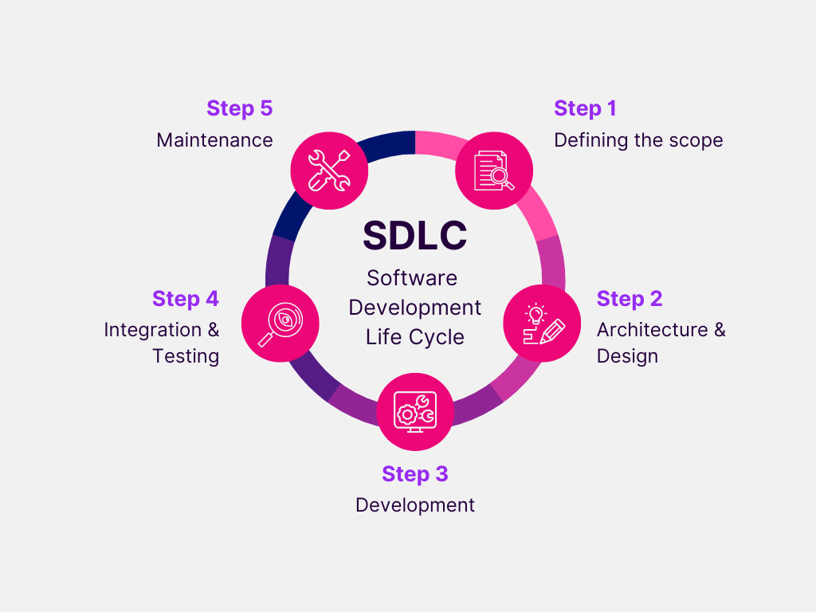

1. defining the scope**:**

Defining the scope of a software development project is a critical step in the Software Development Life Cycle (SDLC). The scope outlines the boundaries and deliverables of the project, specifying what is included and what is not. It helps ensure that all stakeholders have a clear understanding of the project's objectives, deliverables, and constraints, which is essential for effective planning, execution, and management.

2.Architecture and design:

Architecture and design in software development refer to the process of creating the overall structure, components, and interactions of a software system. It involves making high-level decisions about how the system will be organized, how its components will interact, and how it will meet the functional and non-functional requirements specified during the requirements analysis phase of the Software Development Life Cycle (SDLC). Architecture and design are crucial steps that lay the foundation for building scalable, maintainable, and extensible software solutions.

3.development: development is the process of creating, designing, implementing, testing, and maintaining software applications or systems. It encompasses a broad range of activities, methodologies, and technologies aimed at producing high-quality software that meets the needs and requirements of users and stakeholders. Software development involves multiple stages, each with its own set of tasks, tools, and methodologies.

4.Testing: Software testing is a crucial phase in the Software Development Life Cycle (SDLC) that involves verifying and validating the software to ensure that it meets the specified requirements, functions correctly, and performs reliably. Testing helps identify defects, bugs, and issues early in the development process, allowing them to be addressed before the software is deployed to users.

5.maintenance: Software maintenance is the process of modifying, updating, and enhancing software applications or systems after they have been deployed to users. It involves various activities aimed at ensuring that the software continues to meet user needs, performs reliably, and remains compatible with changing environments and requirements.

**Explain each phase of SDLC** :

The Software Development Life Cycle (SDLC) is a systematic process used for developing software. It ensures high-quality software is delivered efficiently and meets or exceeds customer expectations. The SDLC typically consists of the following phases:

1. **Planning and Requirement Analysis:**
   * **Objective:** Define the project's goals, scope, and constraints.
   * **Activities:** Stakeholder meetings, feasibility studies, resource planning, and requirement gathering.
   * **Output:** Project plan, cost estimates, schedule, and requirement specification document.
2. **Defining Requirements:**
   * **Objective:** Clearly specify what the software needs to do.
   * **Activities:** Detailed documentation of functional and non-functional requirements, use case development, and user stories.
   * **Output:** Software Requirement Specification (SRS) document.
3. **Design:**
   * **Objective:** Create the architecture of the software system.
   * **Activities:** System design, data models, architectural design, interface design, and detailed design of modules.
   * **Output:** Design documents, including high-level design (HLD) and low-level design (LLD) documents.
4. **Implementation (or Coding):**
   * **Objective:** Transform design documents into the actual software.
   * **Activities:** Writing code, performing unit testing, and integrating modules.
   * **Output:** Source code, build scripts, and unit test reports.
5. **Testing:**
   * **Objective:** Identify and fix defects to ensure the software meets requirements and is bug-free.
   * **Activities:** Various testing types such as unit testing, integration testing, system testing, and acceptance testing.
   * **Output:** Test plans, test cases, test scripts, and defect reports.
6. **Deployment:**
   * **Objective:** Deliver the final product to the end-users.
   * **Activities:** Deploying the software to a production environment, training end-users, and performing acceptance testing.
   * **Output:** Deployed system, deployment guides, user manuals, and training materials.
7. **Maintenance:**
   * **Objective:** Ensure the software remains functional and up-to-date post-deployment.
   * **Activities:** Bug fixing, updates, enhancements, and performance improvements.
   * **Output:** Maintenance reports, update patches, and new versions/releases of the software.

Each phase in the SDLC has specific deliverables and roles involved, ensuring a structured and efficient approach to software development. The cycle may be iterative, especially in agile methodologies, where phases are revisited as needed to refine and improve the software continually.

The Software Development Life Cycle (SDLC) is a systematic process used for developing software. It ensures high-quality software is delivered efficiently and meets or exceeds customer expectations. The SDLC typically consists of the following phases:

1. **Planning and Requirement Analysis:**
   * **Objective:** Define the project's goals, scope, and constraints.
   * **Activities:** Stakeholder meetings, feasibility studies, resource planning, and requirement gathering.
   * **Output:** Project plan, cost estimates, schedule, and requirement specification document.
2. **Defining Requirements:**
   * **Objective:** Clearly specify what the software needs to do.
   * **Activities:** Detailed documentation of functional and non-functional requirements, use case development, and user stories.
   * **Output:** Software Requirement Specification (SRS) document.
3. **Design:**
   * **Objective:** Create the architecture of the software system.
   * **Activities:** System design, data models, architectural design, interface design, and detailed design of modules.
   * **Output:** Design documents, including high-level design (HLD) and low-level design (LLD) documents.
4. **Implementation (or Coding):**
   * **Objective:** Transform design documents into the actual software.
   * **Activities:** Writing code, performing unit testing, and integrating modules.
   * **Output:** Source code, build scripts, and unit test reports.
5. **Testing:**
   * **Objective:** Identify and fix defects to ensure the software meets requirements and is bug-free.
   * **Activities:** Various testing types such as unit testing, integration testing, system testing, and acceptance testing.
   * **Output:** Test plans, test cases, test scripts, and defect reports.
6. **Deployment:**
   * **Objective:** Deliver the final product to the end-users.
   * **Activities:** Deploying the software to a production environment, training end-users, and performing acceptance testing.
   * **Output:** Deployed system, deployment guides, user manuals, and training materials.
7. **Maintenance:**
   * **Objective:** Ensure the software remains functional and up-to-date post-deployment.
   * **Activities:** Bug fixing, updates, enhancements, and performance improvements.
   * **Output:** Maintenance reports, update patches, and new versions/releases of the software.

Each phase in the SDLC has specific deliverables and roles involved, ensuring a structured and efficient approach to software development. The cycle may be iterative, especially in agile methodologies, where phases are revisited as needed to refine and improve the software continually.

The Software Development Life Cycle (SDLC) is a systematic process used for developing software. It ensures high-quality software is delivered efficiently and meets or exceeds customer expectations. The SDLC typically consists of the following phases:

1. **Planning and Requirement Analysis:**
   * **Objective:** Define the project's goals, scope, and constraints.
   * **Activities:** Stakeholder meetings, feasibility studies, resource planning, and requirement gathering.
   * **Output:** Project plan, cost estimates, schedule, and requirement specification document.
2. **Defining Requirements:**
   * **Objective:** Clearly specify what the software needs to do.
   * **Activities:** Detailed documentation of functional and non-functional requirements, use case development, and user stories.
   * **Output:** Software Requirement Specification (SRS) document.
3. **Design:**
   * **Objective:** Create the architecture of the software system.
   * **Activities:** System design, data models, architectural design, interface design, and detailed design of m The Software Development Life Cycle (SDLC) is a systematic process used for developing software. It ensures high-quality software is delivered efficiently and meets or exceeds customer expectations. The SDLC typically consists of the following phases:
   * Planning and Requirement Analysis:
   * Objective: Define the project's goals, scope, and constraints.
   * Activities: Stakeholder meetings, feasibility studies, resource planning, and requirement gathering.
   * Output: Project plan, cost estimates, schedule, and requirement specification document.
   * Defining Requirements:
   * Objective: Clearly specify what the software needs to do.
   * Activities: Detailed documentation of functional and non-functional requirements, use case development, and user stories.
   * Output: Software Requirement Specification (SRS) document.
   * Design:
   * Objective: Create the architecture of the software system.
   * Activities: System design, data models, architectural design, interface design, and detailed design of modules.
   * Output: Design documents, including high-level design (HLD) and low-level design (LLD) documents.
   * Implementation (or Coding):
   * Objective: Transform design documents into the actual software.
   * Activities: Writing code, performing unit testing, and integrating modules.
   * Output: Source code, build scripts, and unit test reports.
   * Testing:
   * Objective: Identify and fix defects to ensure the software meets requirements and is bug-free.
   * Activities: Various testing types such as unit testing, integration testing, system testing, and acceptance testing.
   * Output: Test plans, test cases, test scripts, and defect reports.
   * Deployment:
   * Objective: Deliver the final product to the end-users.
   * Activities: Deploying the software to a production environment, training end-users, and performing acceptance testing.
   * Output: Deployed system, deployment guides, user manuals, and training materials.
   * Maintenance:
   * Objective: Ensure the software remains functional and up-to-date post-deployment.
   * Activities: Bug fixing, updates, enhancements, and performance improvements.
   * Output: Maintenance reports, update patches, and new versions/releases of the software.
   * Each phase in the SDLC has specific deliverables and roles involved, ensuring a structured and efficient approach to software development. The cycle may be iterative, especially in agile methodologies, where phases are revisited as needed to refine and improve the software continually.
   * odules.
   * **Output:** Design documents, including high-level design (HLD) and low-level design (LLD) documents.
4. **Implementation (or Coding):**
   * **Objective:** Transform design documents into the actual software.
   * **Activities:** Writing code, performing unit testing, and integrating modules.
   * **Output:** Source code, build scripts, and unit test reports.
5. **Testing:**
   * **Objective:** Identify and fix defects to ensure the software meets requirements and is bug-free.
   * **Activities:** Various testing types such as unit testing, integration testing, system testing, and acceptance testing.
   * **Output:** Test plans, test cases, test scripts, and defect reports.
6. **Deployment:**
   * **Objective:** Deliver the final product to the end-users.
   * **Activities:** Deploying the software to a production environment, training end-users, and performing acceptance testing.
   * **Output:** Deployed system, deployment guides, user manuals, and training materials.
7. **Maintenance:**
   * **Objective:** Ensure the software remains functional and up-to-date post-deployment.
   * **Activities:** Bug fixing, updates, enhancements, and performance improvements.
   * **Output:** Maintenance reports, update patches, and new versions/releases of the software.

Each phase in the SDLC has specific deliverables and roles involved, ensuring a structured and efficient approach to software development. The cycle may be iterative, especially in agile methodologies, where phases are revisited as needed to refine and improve the software continually.